Assignment (code refactoring)

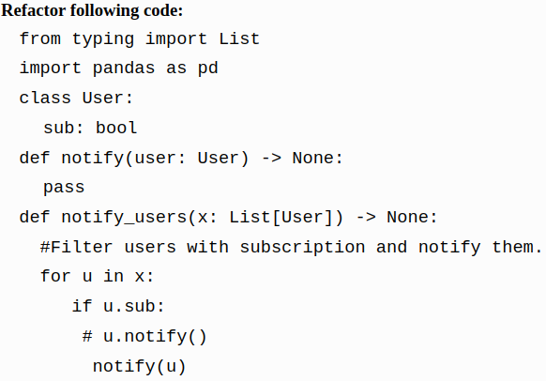

Solution

In above code we find many complications:
- Unused pandas library is imported.
- No use of dataclass.
- It's better to break each task into different functions. So we break subscribers and notify into two functions.

